|  |
| --- |
|  |
| ANT100 Redesign |
| Wireframes and Design Mockups |
|  |
| Maggie Cheung |
| 10/12/2015 |

These are for preview only – these designs may be altered in the process of transitioning from design to implementation into a working website. The main purpose of this preview is to review the organization and flow of information (i.e. titles, subtitles, page order, navigation menu, sub-menus, slider-menu organization of certain pages, mobile version of website). I’ve also included a colour scheme and typography preview, but this can be changed before final implementation. Please leave any comments next to the page mockups using Word commenting functions.

Table of Contents

A Note on Stylistic Elements and What They Represent 5

Image Placeholders 5

Buttons 5

Interactive Buttons and Sliders 5

Breadcrumbs 5

Questions? 5

1. Pages 6

1.1. Page Tree 6

1.2. Design Elements 7

1.2.1. Samples of Colour Palette, Typography, and Button Styles 7

1.3. ANT100 Desktop/Large Screens 8

1.3.1. Header (Navigation Bar) 8

1.3. ANT100 Desktop/Large Screens 9

1.3.2. Desktop Homepage with Highlight Slider 9

1.4. Course Info 10

1.4.1. Course Info: Syllabus Download Button, and Infrequently Updated Information 10

1.5. Lecture Schedule 11

1.5.1. Vertical Accordion Slider that Expand to show Lecture Topics & Readings 11

1.6. Lecture Notes 12

1.6.1. Vertical Accordion Slider that Expand to show Contain Lecture Notes & Study Questions 12

1.7. Essay Main Page 13

1.7.1. Vertical Accordion Slider for Assignment List, expands to show details 13

1.8. Essay Topics 15

1.8.1. Essay Topics, with links to readings 15

1.9. Research 16

1.9.1. Research & Documentation Resources 16

1.10. Formatting 17

1.10.1. Essay Formatting Guide 17

1.11. Plagiarism 18

1.11.1. Plagiarism Policy and Plagiarism Checklist 18

1.12. Writing Help 19

1.12.1. Writing Resource Links 19

1.13. Contact 20

1.13.1. Contact Information & Office Hours 20

1.14. TAs 21

1.14.1. TA Contact List 21

1.15. ANT100 Mobile 22

1.15.1. ANT100 Mobile Header 22

1.15. ANT100 Mobile 23

1.15.2. Mobile Homepage (Colour Simplified) 23

1.15.3. Highlight Slider 24

1.15.3.1. Essay Slide 24

1.15.3.2. Content on the “Essay” Slide of the Highlight Slider 24

1.15.3.3. Evaluation 24

1.15.3.4. Content on the “Evaluation” Slide of the Highlight Slider 24

1.15.3.5. Lectures 25

1.15.3.6. Content on the “Lectures” Slide of the Highlight Slider 25

1.16. Course Info 26

1.16.1. Course Info: Syllabus Download Button, and Infrequently Updated Information 26

1.17. Lectures 27

1.17.1. Vertical Accordion Slider that Expand to show Lecture Topics & Readings 27

1.18. Lecture Notes 28

1.18.1. Vertical Accordion Slider that Expand to show Contain Lecture Notes & Study Questions 28

1.19. Essay Main Page 29

1.19.1. Vertical Accordion Slider for Assignment List, expands to show details 29

1.20. Essay Topics 30

1.20.1. Essay Topics, with links to readings 30

1.21. Research 31

1.21.1. Research & Documentation Resources 31

1.22. Formatting 32

1.22.1. Essay Formatting Guide 32

1.23. Plagiarism 33

1.23.1. Plagiarism Policy and Plagiarism Checklist 33

1.24. Writing Help 34

1.24.1. Writing Resource Links 34

1.25. Contact 35

1.25.1. Contact Information & Office Hours 35

1.26. TAs 36

1.26.1. TA Contact List 36

# A Note on Stylistic Elements and What They Represent

## Image Placeholders

This is a fairly straightforward design guide but for those who may be wondering, the boxes with ‘X’s crossed through them represent images. These are suggested placement locations for images to augment or highlight content.

## Buttons

You will notice there are four main types of buttons (See **1.2 Design Elements** on page 5). These are designed to be very obviously clickable buttons. The four colours can be used to colour-code different types of buttons or to highlight certain clickable content.

### **Interactive Buttons and Sliders**

You may also notice that the homepage (1.3.1) has an unusual pill-shaped trio of buttons under “Important Info” – notes on the design layout will tell you what those buttons will do when clicked.

There are also slider elements on other pages (Lectures, Essay) and their subpages. Notes will be provided on following pages about the content they contain and how the user may interact with them.

## Breadcrumbs

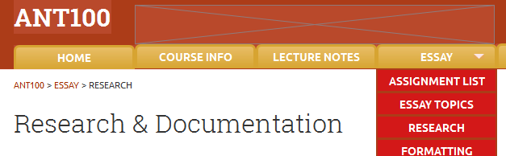I’ve added a breadcrumb trail under the header because of how large this website is. Since there are two levels of webpage organization, the breadcrumb trail helps students locate where they are in the page hierarchy, and allows them to move back upwards in the hierarchy easily.

The current page is shown in black type.

The higher levels of the website organizations can be navigated to by clicking earlier items in the breadcrumb trail.

This is the current page. Clicking on the “Essay” link in the breadcrumb trail will lead students to the Essay Main Page (see **1.7 Essay Main Page**), which can also be accessed by clicking the “Assignment List” in this Essay submenu.

# Questions?

If you have any questions, concerns, and/or suggestions, please feel free to contact me:

**Maggie Cheung**[magnolia.cheung@mail.utoronto.ca](mailto:magnolia.cheung@mail.utoronto.ca)

Alternatively, you may direct your concerns directly to **Prof. Ivan Kalmer**, who is currently supervising this project.

1. Pages
   1. Page Tree

Design Elements

ANT100 Desktop/Large Screens  
 Header (Navigation Bar)  
 Course Info  
 Lecture  
 Lecture Notes  
 Essay Main Page  
 Essay Topics  
 Research  
 Formatting  
 Plagiarism  
 Writing Help  
 Contact  
 TAs  
ANT100 Mobile  
 ANT100 Mobile Header  
 Course Info  
 Lectures  
 Lecture Notes  
 Essay  
 Essay Topics  
 Research  
 Formatting  
 Plagiarism  
 Writing Help  
 Contact  
 TAs

* 1. Design Elements
     1. Samples of Colour Palette, Typography, and Button Styles

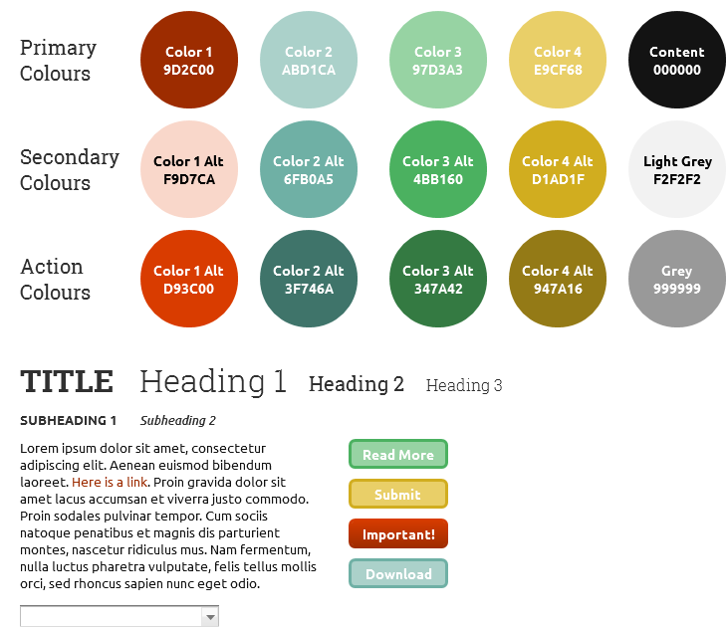

**Please note that typography and colour palette may be subject to change.**

Most notably, Prof. Kalmer has requested that the body font (“Ubuntu” in this design mockup) be set to “Open Sans”.

* 1. ANT100 Desktop Header
     1. Header (Navigation Bar) with expanded submenu

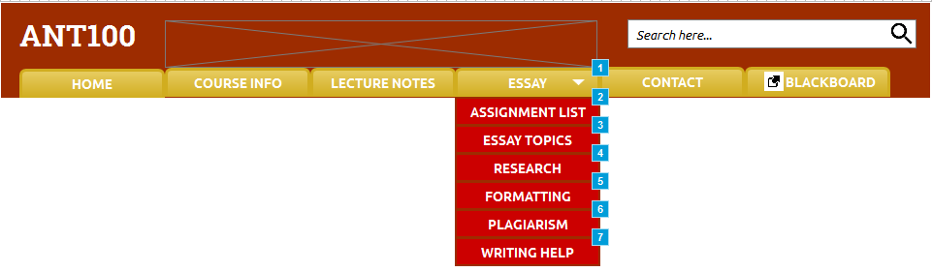

This submenu appears when “ESSAY” is clicked.

This is an external link to Blackboard, placed here for convenience.

* 1. ANT100 Desktop/Large Screens
     1. Desktop Homepage with Highlight Slider

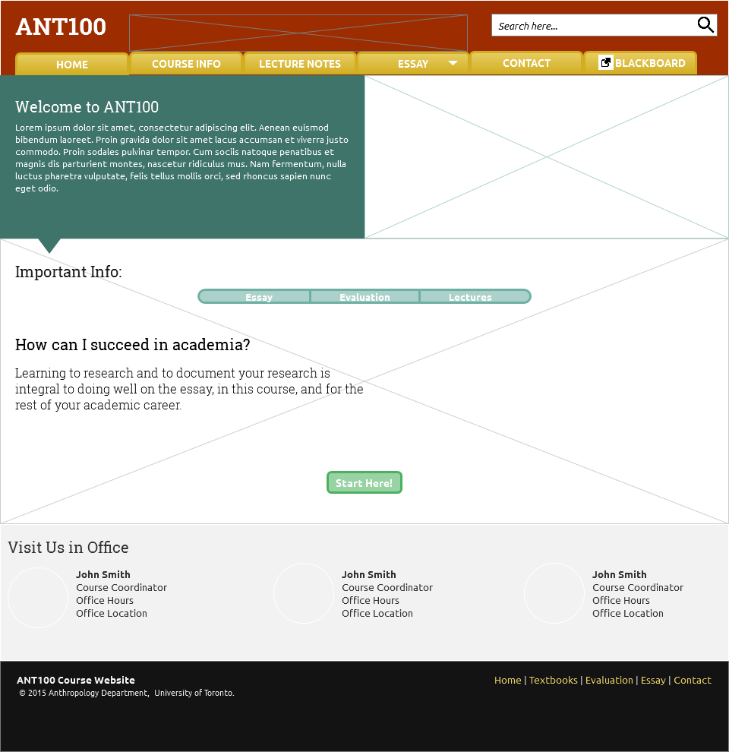

**Highlight Slider**

These are buttons that control the slider. When clicked, the information at left, the image behind this section, and the button below will all slide to the left. The button clicked on determines which “slide” of content will be revealed.

***See 1.15.2 (page 21) for examples***

* 1. Course Info
     1. Course Info: Syllabus Download Button, and Infrequently Updated Information

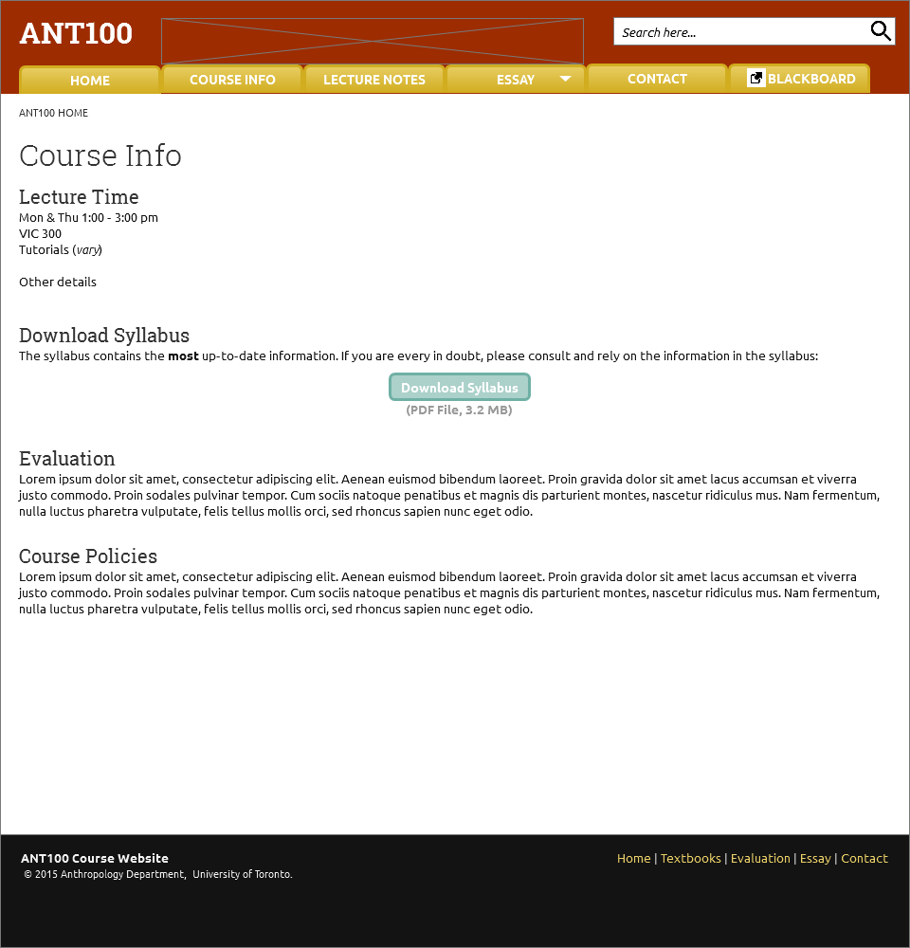

This syllabus will only need to be uploaded every year. As long as the file name is kept the same year-to-year, and the file is uploaded into the same folder, this link will allow students to download the syllabus directly from the website.

* 1. Lecture Schedule
     1. Vertical Accordion Slider that Expand to show Lecture Topics & Readings

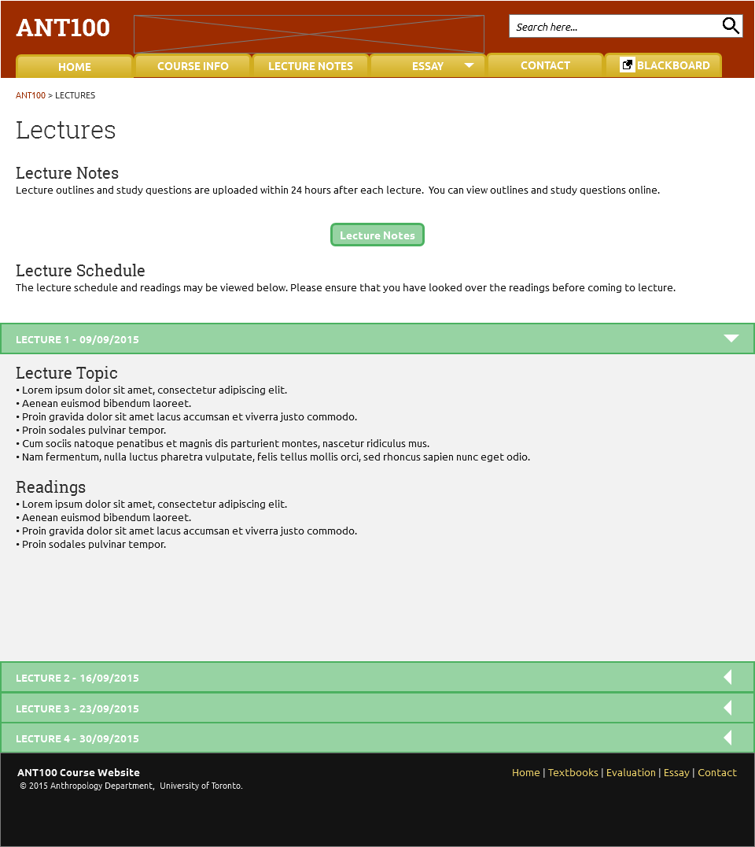

Clicking on this green bar will expand the grey content section shown here.

* 1. Lecture Notes
     1. Vertical Accordion Slider that Expand to show Contain Lecture Notes & Study Questions

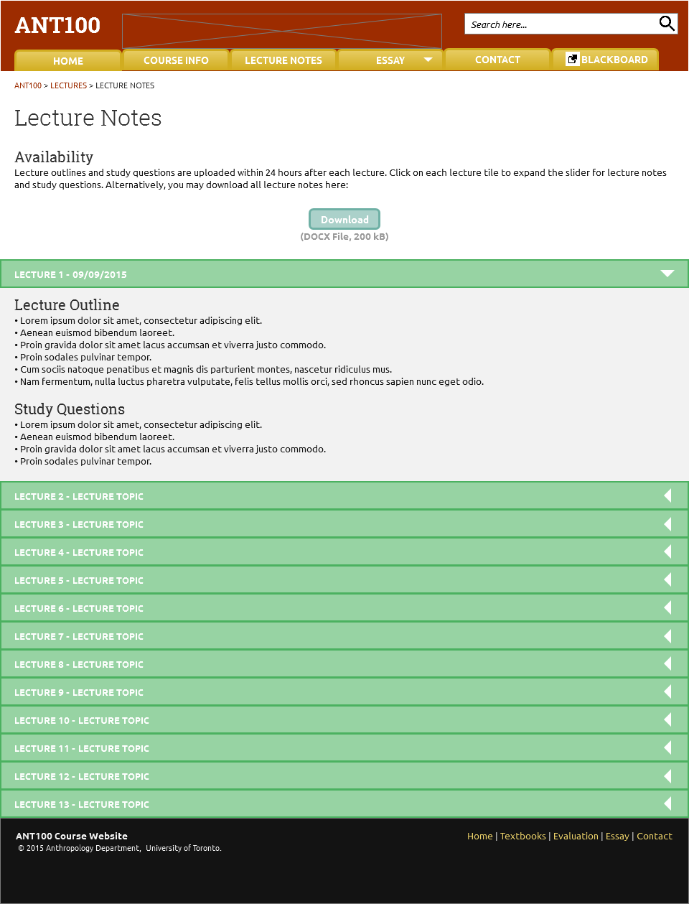

Clicking on this green bar will expand the grey content section shown here.

* 1. Essay Main Page
     1. Vertical Accordion Slider for Assignment List, expands to show details

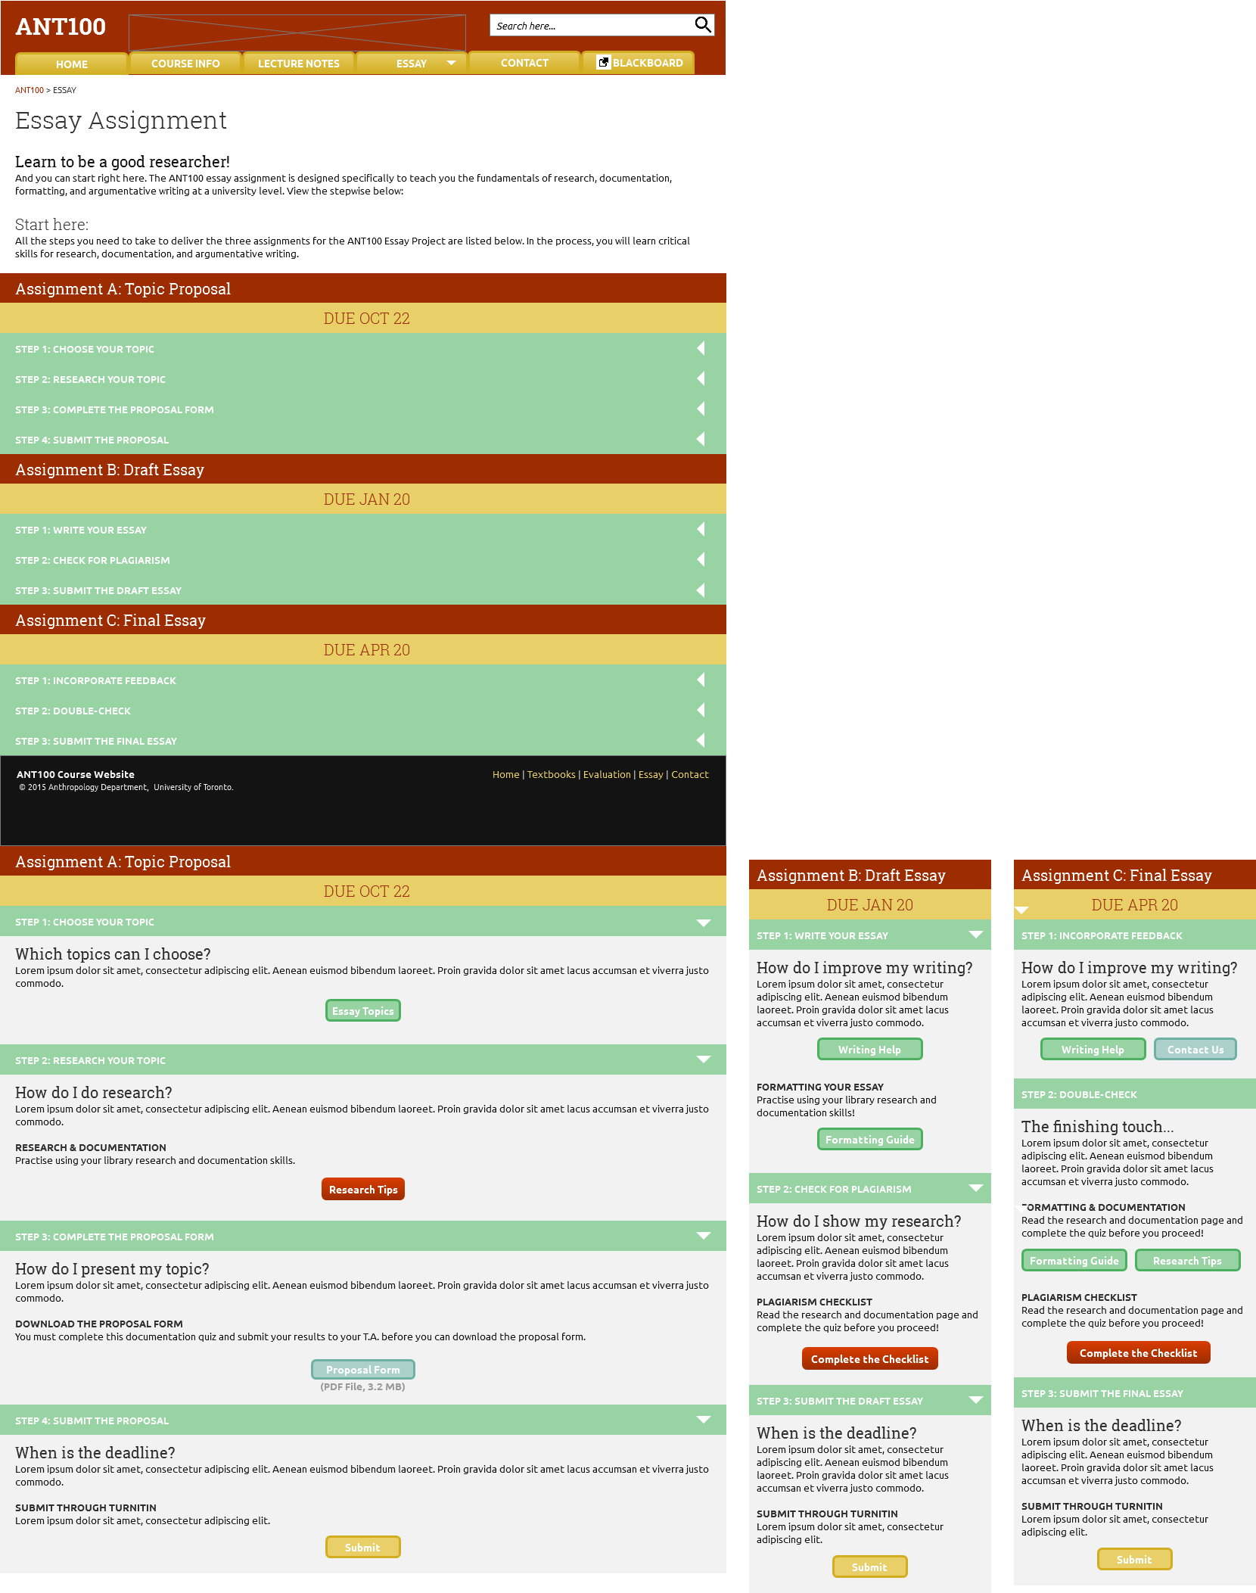

The essay is organized as three separate assignments, with due dates clearly shown so that students understand that they must hand in three deliverables in the essay process.

Process details are shown in the expandable sliders.

Clicking on this green bar will expand the grey content sections. The content itself is shown below, and in the next page.



* 1. Essay Topics
     1. Essay Topics, with links to readings

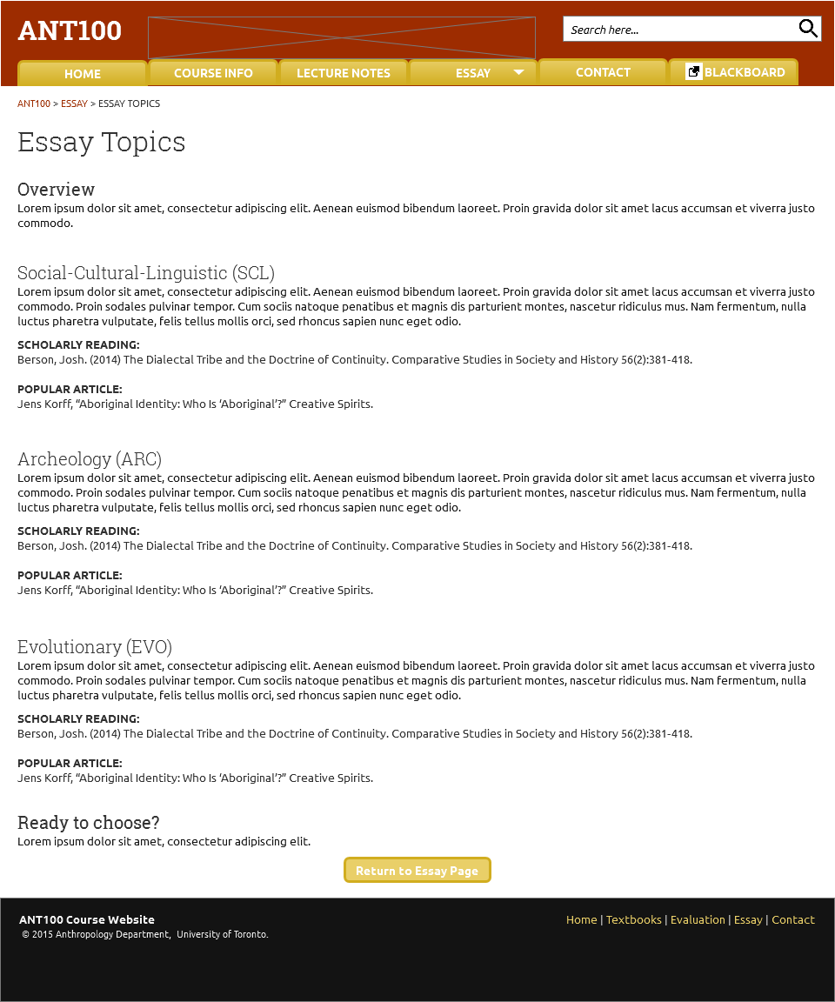

Every page related to the essay has a button leading back to the essay main page.

* 1. Research
     1. Research & Documentation Resources

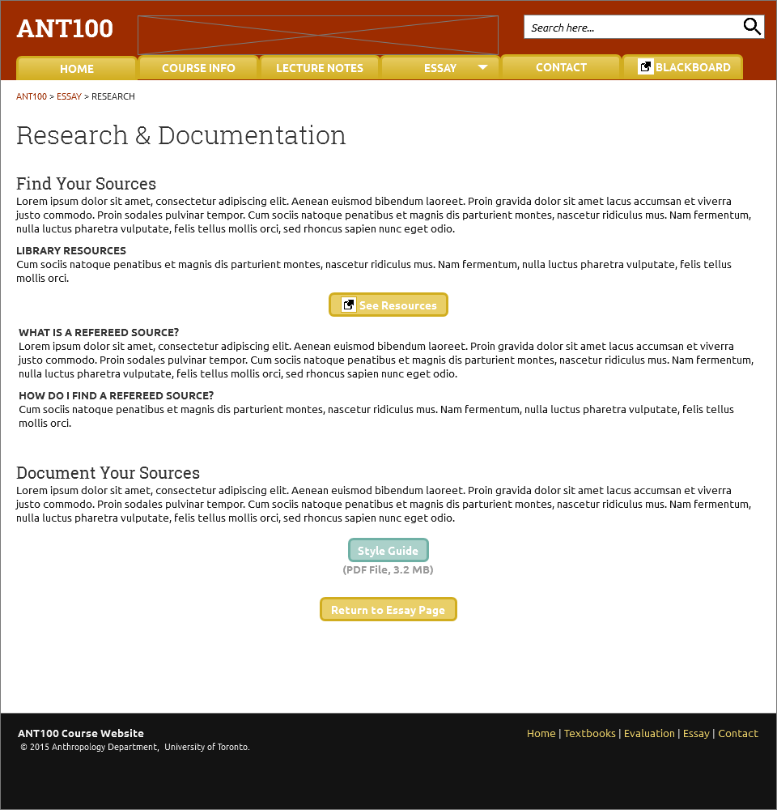

Ideally, a quiz will be implemented that students will have to complete before they can submit their proposal form on the essay main page.

* 1. Formatting
     1. Essay Formatting Guide

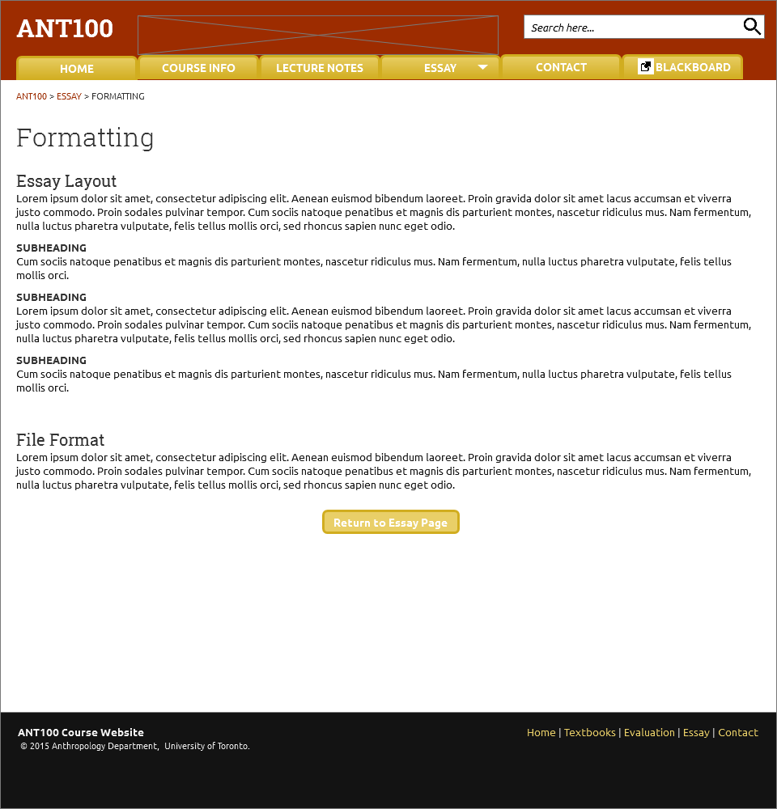

* 1. Plagiarism
     1. Plagiarism Policy and Plagiarism Checklist

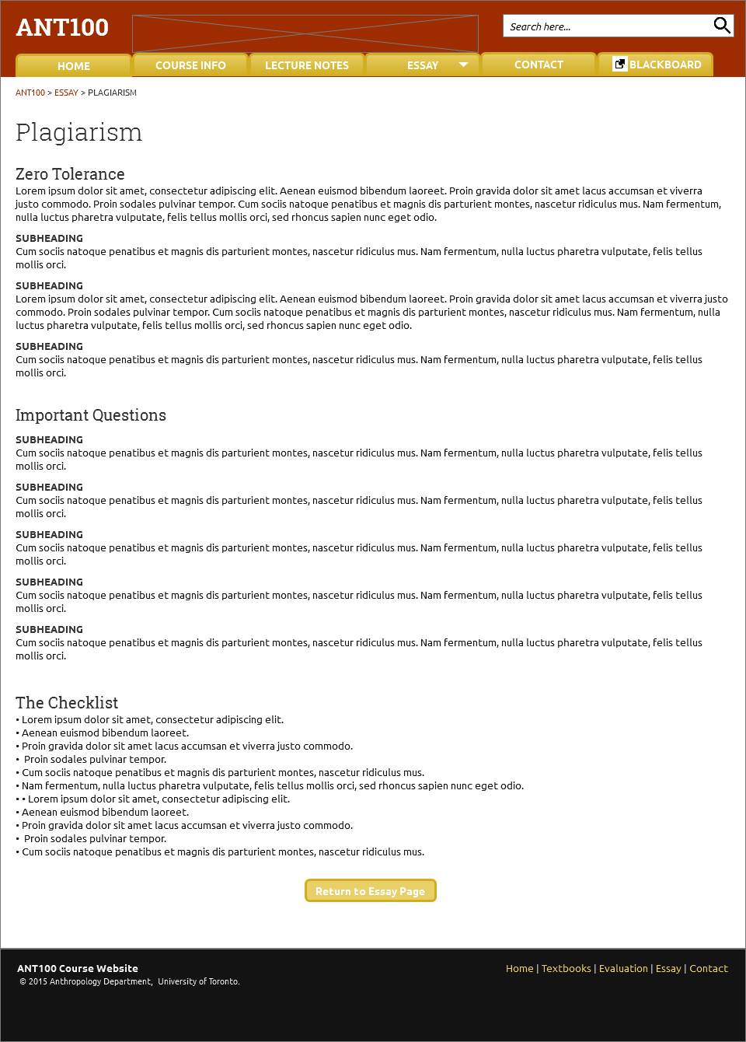

Ideally, this checklist will be implemented as an interactive checklist which students must actually check off and submit (an email will be sent their TA).

* 1. Writing Help
     1. Writing Resource Links

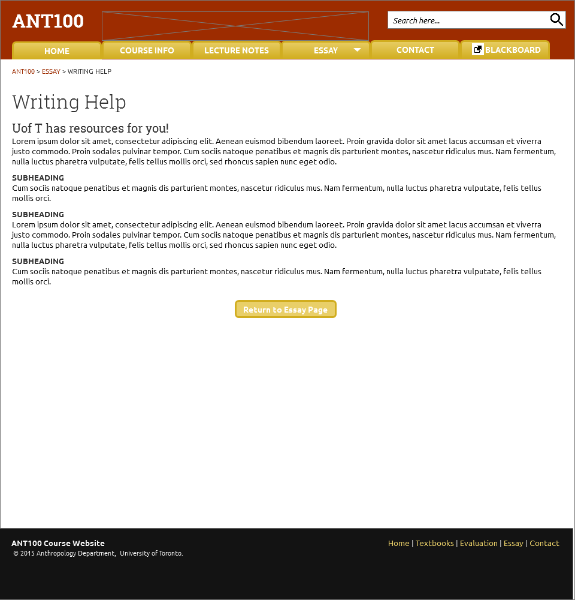

* 1. Contact
     1. Contact Information & Office Hours

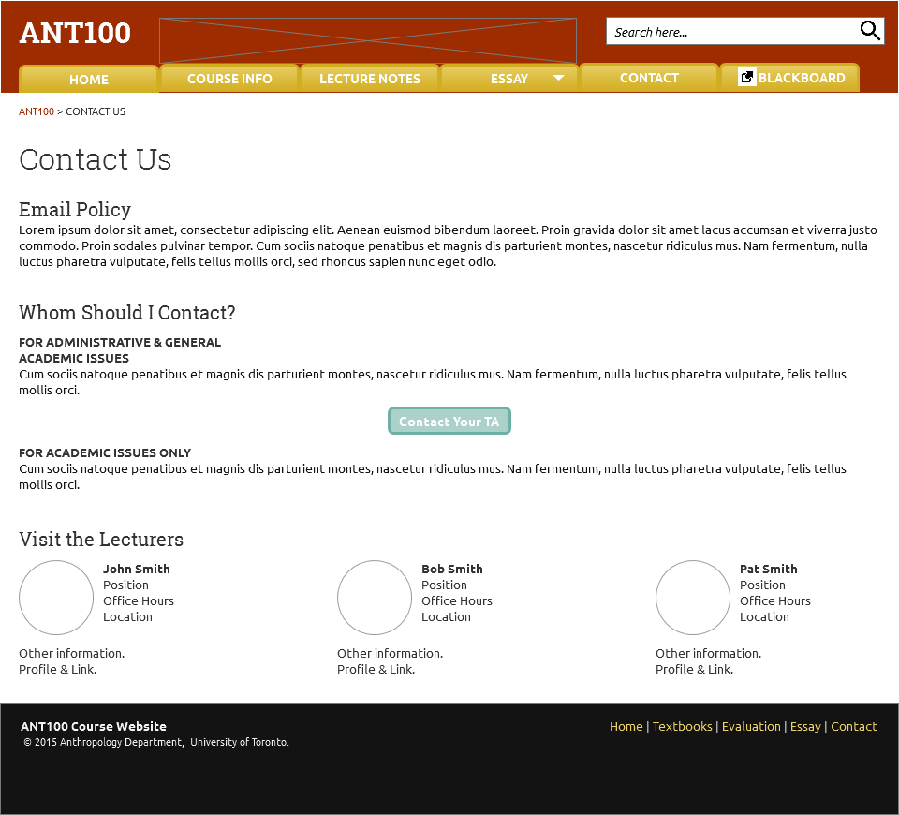

* 1. TAs
     1. TA Contact List

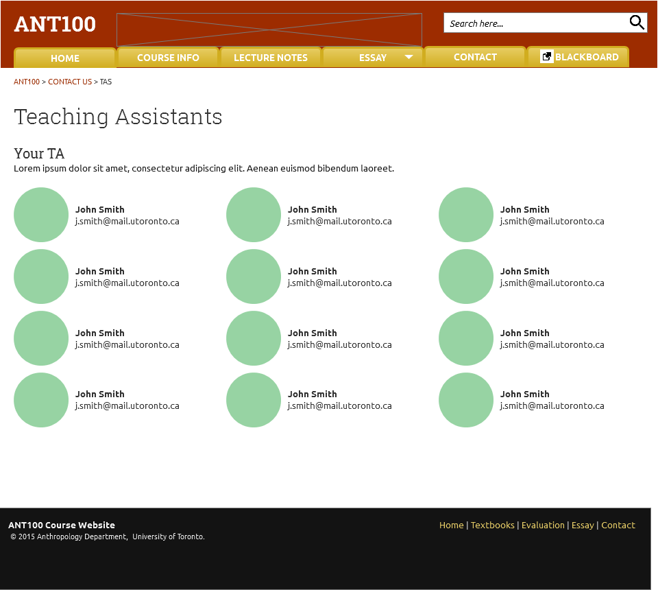

Will be a link that will directly open an email composition window.

* 1. ANT100 Mobile Header
     1. Header (Navigation Bar) with expanded submenu

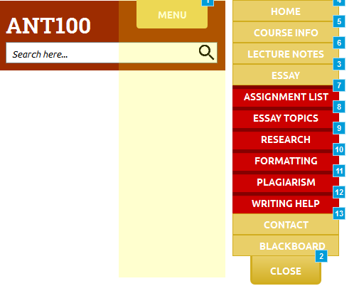

On a touch-screen, this can be slid down to reveal the menu shown expanded at right.

The essay submenu expands once “ESSAY” is tapped.

* 1. ANT100 Mobile
     1. Mobile Homepage (Colour Simplified)

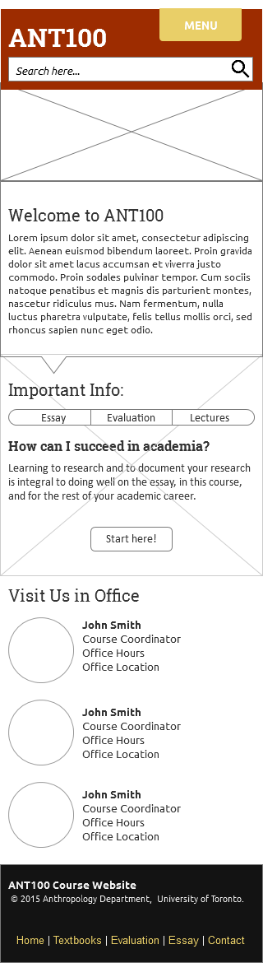

Clicking these buttons causes the background image of this section, and the content below the buttons to change. See the changed content on the next two pages.

* + 1. Highlight Slider
       1. Essay Slide
       2. Content on the “Essay” Slide of the Highlight Slider

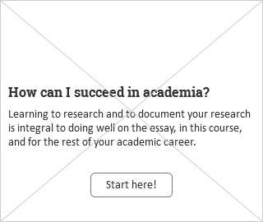

* + - 1. Evaluation
      2. Content on the “Evaluation” Slide of the Highlight Slider

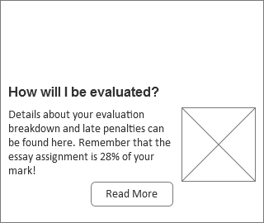

* + - 1. Lectures
      2. Content on the “Lectures” Slide of the Highlight Slider

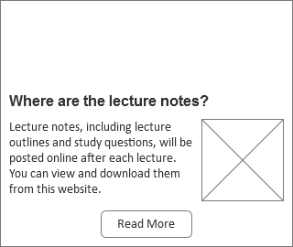

* 1. Course Info
     1. Course Info: Syllabus Download Button, and Infrequently Updated Information

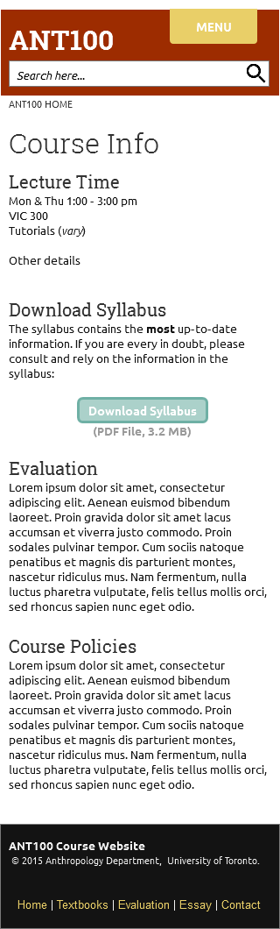

* 1. Lectures
     1. Vertical Accordion Slider that Expand to show Lecture Topics & Readings

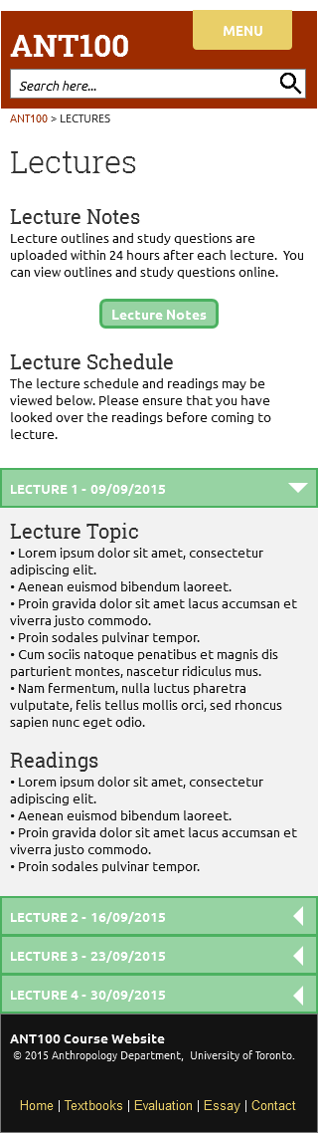

* 1. Lecture Notes
     1. Vertical Accordion Slider that Expand to show Contain Lecture Notes & Study Questions

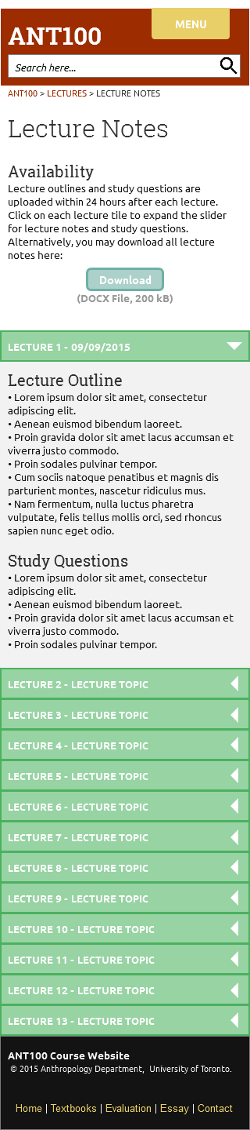

* 1. Essay Main Page
     1. Vertical Accordion Slider for Assignment List, expands to show details

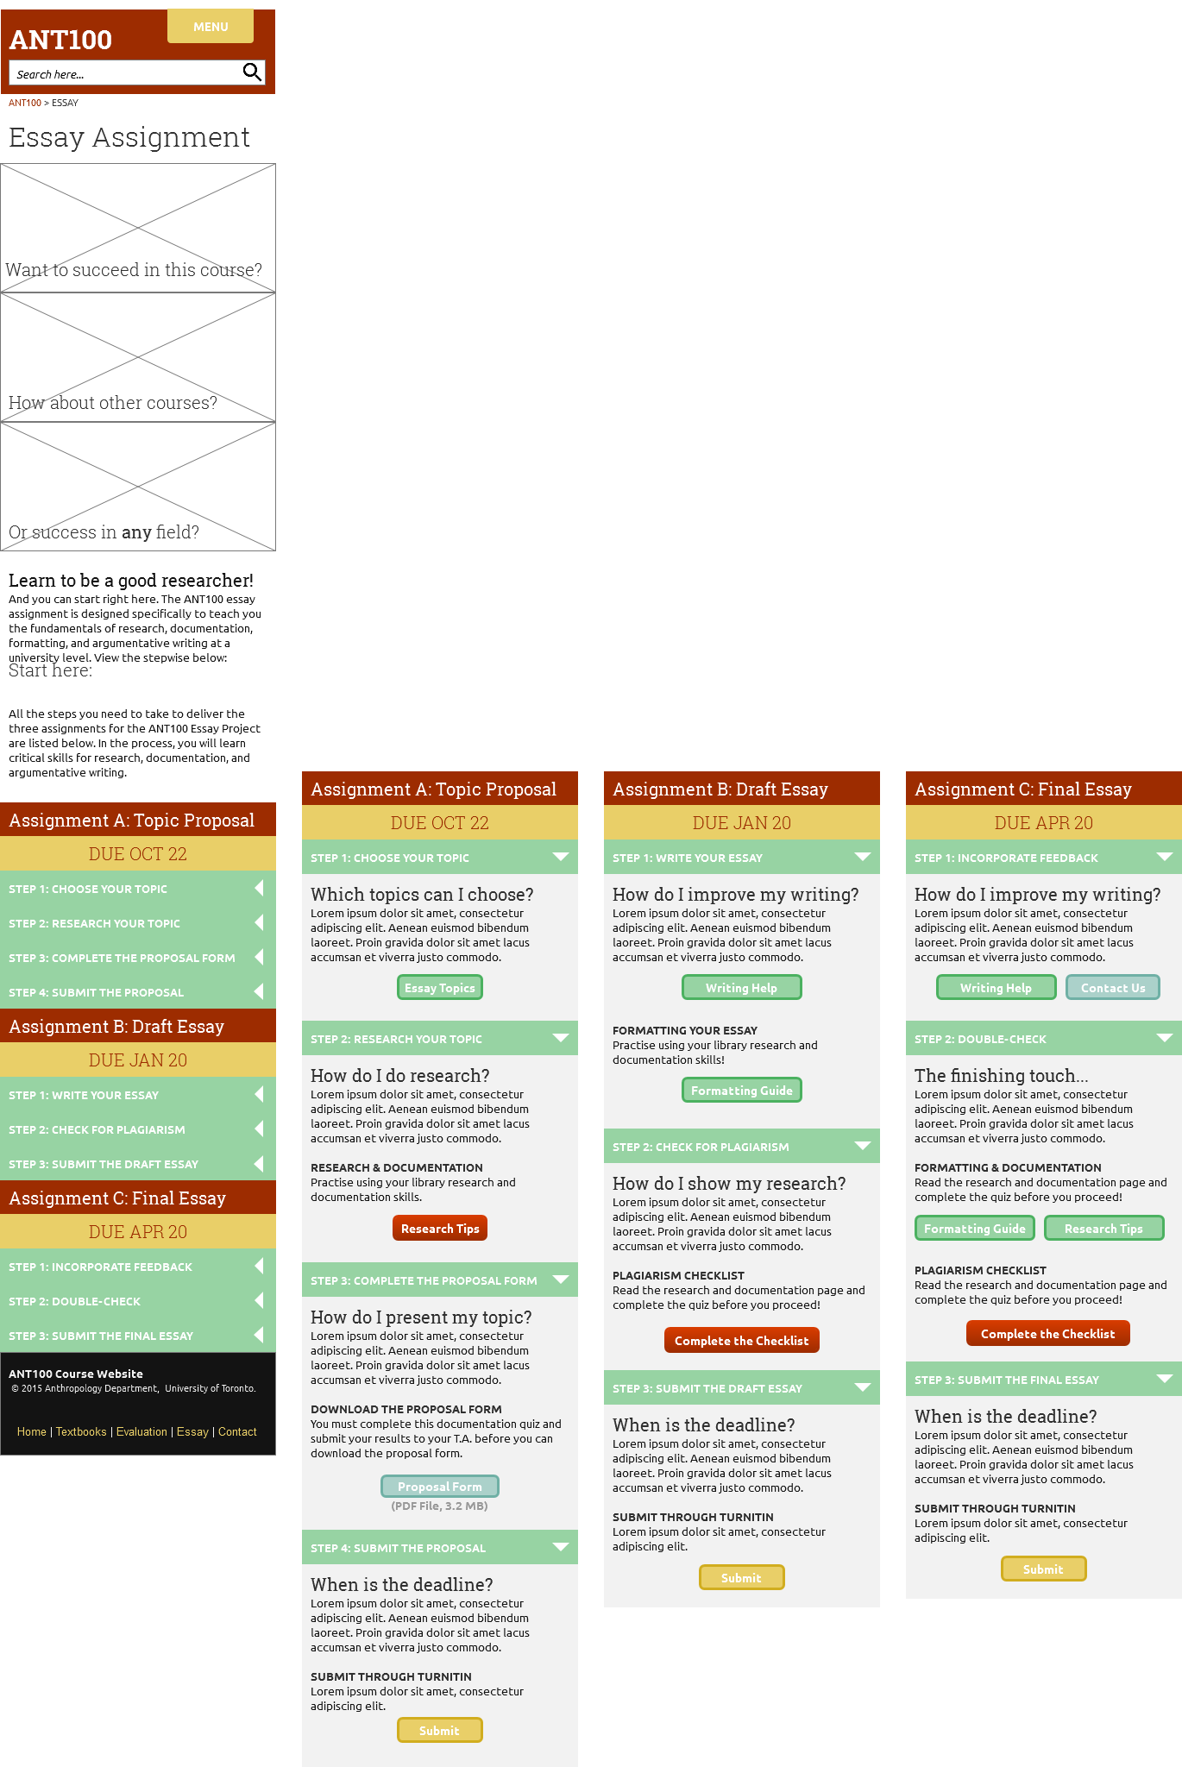

This is an option: can put image banners here with captions that will lead students into this page.

* 1. Essay Topics
     1. Essay Topics, with links to readings

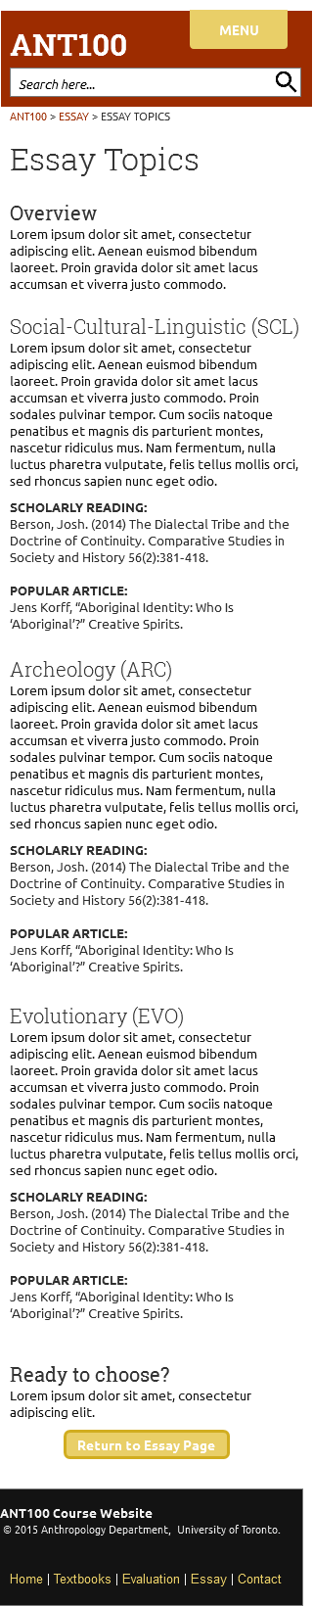

* 1. Research
     1. Research & Documentation Resources

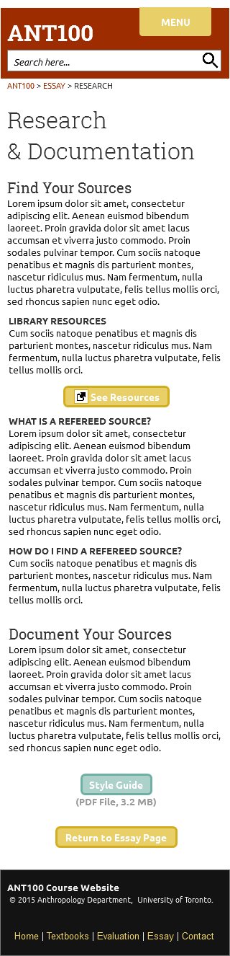

* 1. Formatting
     1. Essay Formatting Guide

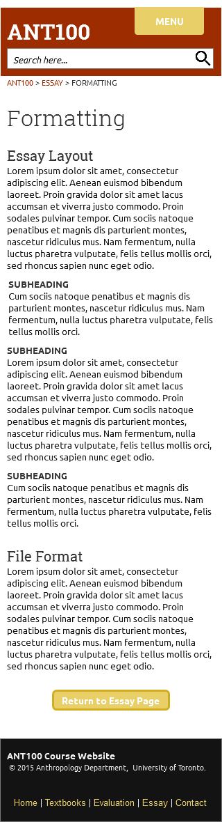

* 1. Plagiarism
     1. Plagiarism Policy and Plagiarism Checklist

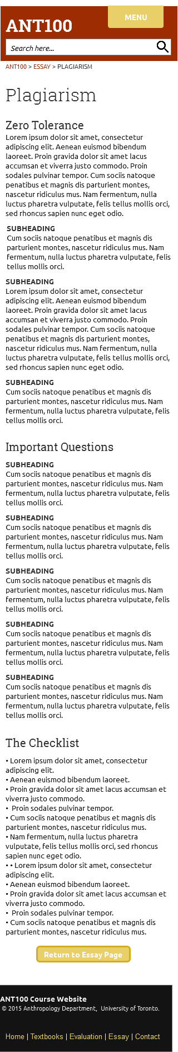

* 1. Writing Help
     1. Writing Resource Links

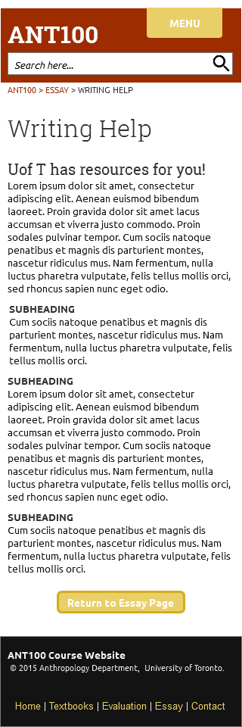

* 1. Contact
     1. Contact Information & Office Hours

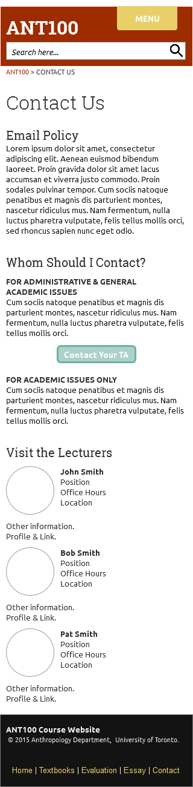

* 1. TAs
     1. TA Contact List

